Synopsis

Predict whether a customer will default on a loan

Problem Id: 2

Abhinav Lakhera
2028612
Q
Parjeet Singh
2028412
Q
Arnav Rawat
2028398
Q

- Problem Description:
Loan default prediction is a critical problem in the banking and financial sector, where institutions aim to identify customers who are likely to fail in repaying their loans. The objective of this project is to design and develop an end-to-end machine learning classification system that can accurately predict loan defaults using customer banking data. The dataset typically includes demographic information, financial details, credit history, and repayment behavior, which are analyzed to uncover patterns associated with default risk.

The project begins with exploratory data analysis (EDA) to understand data distributions, detect outliers, and identify relationships between variables. This is followed by data preprocessing steps such as handling missing values, encoding categorical variables, and applying normalization techniques. To manage high-dimensional data and improve efficiency, dimensionality reduction is performed using Principal Component Analysis (PCA).

The system implements classification algorithms including Support Vector Machine (SVM) with various kernel functions and K-Nearest Neighbours (K-NN). Finally, model performance is evaluated using metrics such as precision, recall, F1-score, and ROC-AUC. This project demonstrates a complete machine learning pipeline from raw data processing to model evaluation, ensuring reliable and efficient prediction of loan defaults, emphasizing best practices in preprocessing, model selection, and performance assessment.

- Steps of Implementation:

This section should explain the each phase of ML pipeline used:
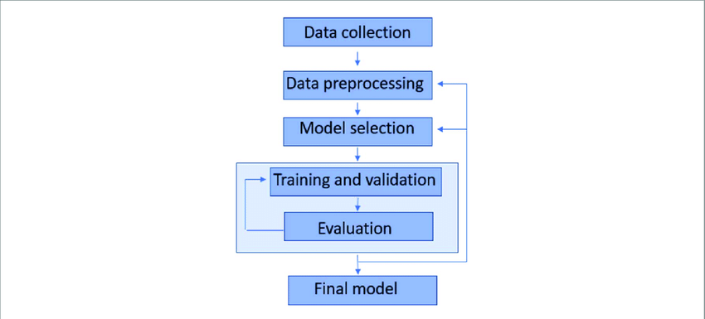

1. Data Collection
This is the first step where raw data is gathered.
- Data includes banking information such as:
  - Income
  - Loan amount
  - Credit history
  - Employment status
  - Repayment history
- Data can be collected from:
  - Bank databases
  - Financial datasets (CSV, Excel, APIs)
- The goal is to obtain relevant data for prediction.

2. Data Preprocessing
This is the most important phase where raw data is cleaned and prepared.
- Data Cleaning
  - Handle missing values (mean/median)
  - Remove duplicates
  - Fix inconsistent data
- Data Transformation
  - Convert categorical data (e.g., gender, job) into numerical form (Encoding)
- Normalization / Scaling
  - Scale features using techniques like Min-Max Scaling or Standardization
- Outlier Detection
  - Identify and remove abnormal values that can affect model performance
- Dimensionality Reduction (PCA)
  - Helps in handling high-dimensional data and improves efficiency

3. Exploratory Data Analysis (EDA)
Helps to understand the dataset before modelling.

- Tasks include:
- Analyze data distribution (histograms, box plots)
- Find relationships between variables (correlation matrix)
- Identify important features affecting loan default

4. Model Selection
- Models used:

- Support Vector Machine (SVM)
  - Linear Kernel → for linearly separable data
  - Polynomial Kernel → for complex relationships
  - RBF Kernel → for non-linear patterns
- K-Nearest Neighbors (K-NN)
  - Classifies based on nearest data points
- The goal is to select models suitable for the dataset characteristics.

5. Training and Validation
- Split dataset into:
  - Training set (to train model)
  - Testing/Validation set (to evaluate performance)
- Process:
- Train models using training data
- Tune hyperparameters (e.g., K in K-NN, kernel type in SVM)
- Use cross-validation to avoid overfitting

6. Model Evaluation
Measure how well the model performs
- Metrics used:
- Precision → Accuracy of positive predictions
- Recall → Ability to detect actual defaulters
- F1-Score → Balance between precision and recall
- ROC-AUC → Overall performance across thresholds
- Compare SVM (different kernels) and K-NN models

7. Final Model Selection
- Choose the best-performing model based on evaluation metrics
- Ensure:
  - High accuracy
  - Good generalization
  - Balanced precision & recall

- Expected Modules/ Libraries to be used :

1. Inbuilt / Standard Libraries
- os
Used for interacting with the operating system (file paths, directories, etc.).
- sys
Provides system-specific parameters and functions (e.g., command-line arguments).
- math
Used for basic mathematical operations like square root, logarithms, etc.
- datetime
Helps handle date and time data (useful for time-based features).

2. Data Handling & Analysis Libraries
- NumPy
Provides support for numerical computations and array operations.
- Pandas
Used for data manipulation, cleaning, and handling datasets (DataFrames).

- Expected Evaluation metrics and Plots to be used:

1. Data Visualization Libraries (EDA)
- Matplotlib
Used to create basic plots like graphs, histograms, and charts.
- Seaborn
Advanced visualization library for statistical plots like heatmaps and pairplots.
2. Machine Learning Libraries
- Scikit-learn
Main library for implementing ML models and preprocessing techniques.
Common modules used from Scikit-learn:
  - sklearn.model_selection → Train-test split, cross-validation
  - sklearn.preprocessing → Scaling, encoding
  - sklearn.decomposition → PCA implementation
  - sklearn.svm → Support Vector Machine
  - sklearn.neighbors → K-NN algorithm
  - sklearn.metrics → Evaluation metrics

3. Model Evaluation Libraries
- sklearn.metrics
Provides functions to calculate precision, recall, F1-score, and ROC-AUC.

- Required topics from the subject:

1. AI and ML Basics:
Libraries required to perform tasks and manage data.
2. Data Preprocessing:
Cleaning and preparing data before training (Handling missing values, encoding data, outlier detection).
3. Model Selection:
Choosing best algorithm based on their performance.
4. Model Evaluation Metrics:
Used to measure performance of classification models(F1-Score)
5. Exploratory Data Analysis (EDA):
Understand data before modeling(pattern identification, graphs, plots)
6. Supervised Learning:
Learning using labeled data. Used for classification problems.

- Platform Required:
Python
Jupyter Notebook
Python Libraries(Pandas, NumPy, Matplotlib, Scikit-learn)
- Books and Link Sources:
Git Hub, Pandas, NumPy, Scikit-Learn, AI

